

PANGANI GIRLS’ KCSE PREDICTION
EXAM TEST-2025
232/1
PHYSICS
PAPER 1
TIME: 2 HOURS

NAME…………………………………………………………………………………………
SCHOOL………………………………………………. SIGN……………………..
INDEX NO ……………………………………………. DATE…………………….

Kenya Certificate of Secondary Education.

Instructions to candidates
1. Write your name, index number and school in the spaces provided above.
2. Sign and write the date of examination in the spaces provided above.
3. This paper consist of TWO sections; A and B.
4. Answer ALL the questions in section A and B in the spaces provided.
5. ALL working MUST be clearly shown.
FOR EXAMINERS USE ONLY
MAXIMUM SCORE | 80 MARKS
CANDIDATE’S SCORE

SECTION A: 25marks
1. A stopwatch is used to time a runner in a race. Figure below show the stopwatch at the start and at the end of a lap of the race.
State how long( in SI unit) did the runner took to finish the lap of the race (1mark)
…………………………………………………………………………………………………

2. The front views of two cars are shown in figure below, drawn to the same scale.
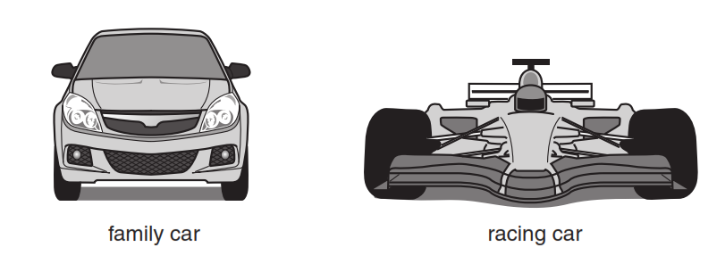
Suggest which car has the greater stability,and give a reason. (2marks)
………………………………………………………………………………………………………
………………………………………………………………………………………………………
………………………………………………………………………………………………………
………………………………………………………………………………………………………
…….

3. Figure below shows a micrometer screw gauge. State the reading indicated (2marks)
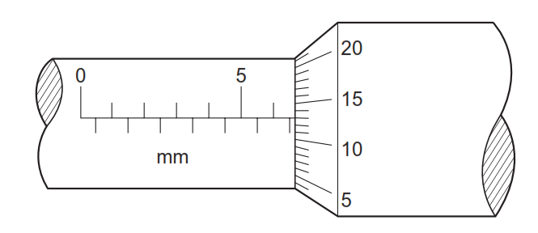
………………………………………………………………………………………………………

4. Figure 4 shows two identical springs of spring constant 3N/cm supporting a load of 30N.
Determine the extension of each spring. (2 marks)
………………………………………………………………………………………………………
………………………………………………………………………………………………………
………………………………………………………………………………………………………
………………………………………………………………………………………………………

5..Figure below shows a system for raising a heavy piece of metal into a vertical position.
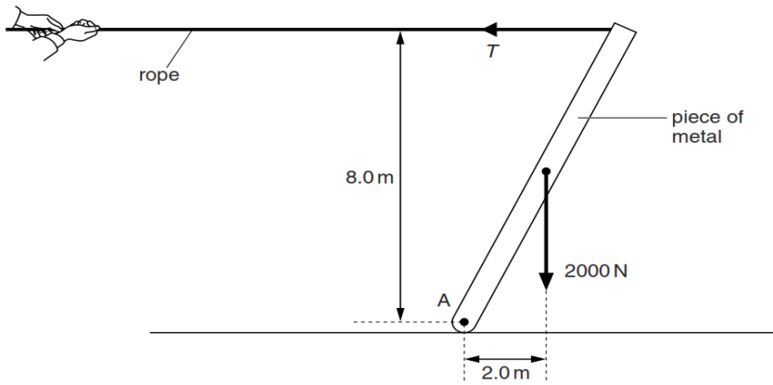

A man pulls on the rope with a horizontal force T. The piece of metal has a weight of
2000 N and is freely pivoted at A. The system is in equilibrium. By taking moments about A, calculate T. (3marks)
………………………………………………………………………………………………………
………………………………………………………………………………………………………
………………………………………………………………………………………………………
………………………………………………………………………………………………………
………………………………………………………………………………………………………

6. Explain why an aeroplane is likely to take off much earlier than expected when the speed of the wind blowing in the opposite direction to its motion on the runway suddenly increases2 mks)
………………………………………………………………………………………………………
………………………………………………………………………………………………………
………………………………………………………………………………………………………

7.An aircraft 300m from the ground traveling horizontally at 400m/s releases a parcel. Calculate the horizontal distance covered by the parcel from the point of release. (Ignore air resistance)
(3 marks).
………………………………………………………………………………………………………
………………………………………………………………………………………………………
………………………………………………………………………………………………………
………………………………………………………………………………………………………
………………………………………………………………………………………………………

8.A body of mass 4.0kg held at a vertical height of 500cm is released to travel a long a frictionless curved path as shown below.
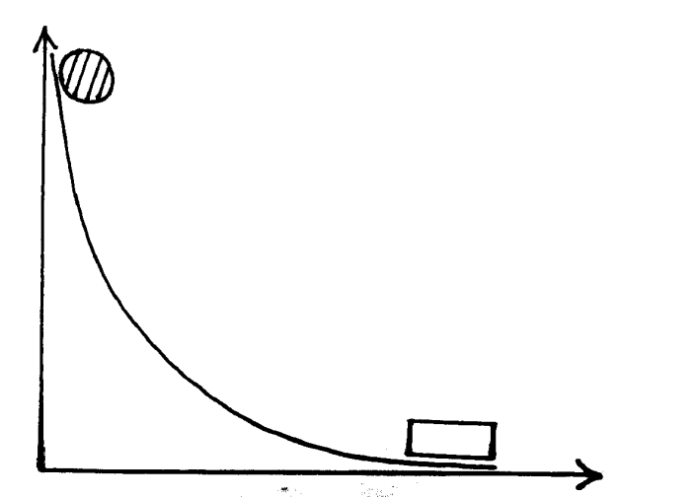
Mass = 4.0kg
Mass = 6.0kg

The 4.0kg mass strikes another body of mass 6.0kg at rest immediately it reaches the horizontal the bodies stick together and move in the same direction. Determine the velocity of the bodies immediately after collision. (3marks)
………………………………………………………………………………………………………
………………………………………………………………………………………………………
………………………………………………………………………………………………………
………………………………………………………………………………………………………
………………………………………………………………………………………………………

9.A tin with a hole is filled with water to a certain height. Water jets out as shown in figure 9(a) below. A second identical tin is filled with water to the same height and a block of wood floated as shown in figure 9(b).
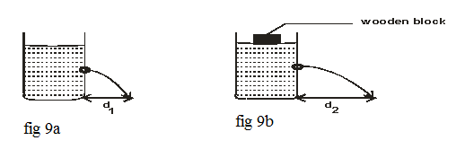
State the reason why the maximum distance of jet d₂ is greater than d₁. (1 mark)
………………………………………………………………………………………………………
………………………………………………………………………………………………………

10.The figure 2 below shows the apparatus used to observe Brownian motion using a smoke cell.

i) State the observation made in the smoke cell. (1 mark)
…………………………………………………………………………………………………………………………………………………………………………………………………………

ii) Explain the observation made when the temperature in the smoke cell is increased. (1 mark)
………………………………………………………………………………………………………………………………………………………………………………………………………………………………………………………………………………………………………………

11. When a mercury in a glass thermometer is used to measure the temperature of hot water, it is observed that the mercury level first drops before beginning to rise. Explain. (2 marks)
……………………………………………………………………………………………………………………………………………………………………………………………………………………………………………………………………………………………………………………………………………………………………………………………………………………

12. Figure 3 shows an arrangement of apparatus to study properties of different surfaces.
The heater is placed equidistance from the two plates. State what happens when the heater is switched on for some time. (1 mark)
………………………………………………………………………………………………………………………………………………………………………………………………………………………………………………………………………………………………………………

13. Expain your answer in question 12 above (1mark)
………………………………………………………………………………………………………
………………………………………………………………………………………………………
………………………………………………………………………………………………………

SECTION B: 55marks
14. a) The figure below shows the features of a refrigerator.
i) What is the function of the pump? (1 mark)
……………………………………………………………………………………………………………………………………………………………………………………………………………
ii) What is the function of the copper fins at the back of the refrigerator? (1 mark)
……………………………………………………………………………………………………………………………………………………………………………………………………………
iii) Explain briefly how cooling takes place in the refrigerator. (3 marks)
……………………………………………………………………………………………………………………………………………………………………………………………………………………………………………………………………………………………………………………………………………………………………………………………………………………………………………………………………………………………………………………………
iv)What is the purpose of the double wall in a refrigerator? (1 mark)
……………………………………………………………………………………………………………………………………………………………………………………………………………

b) i) Define the term latent heat of fusion of a substance. (1 mark)
………………………………………………………………………………………………………
………………………………………………………………………………………………………
………………………………………………………………………………………………………

ii) The figure below shows an apparatus that could be used to determine the specific latent heat of fusion of ice.
In order to obtain results that are as accurate as possible, state why it is important to:
I. wait until water is dripping into the beaker at constant rate before taking readings. (1 mark)
……………………………………………………………………………......……………….......
....................................................................................................................

II. Use finely crushed ice rather than larger ones. (1 mark)
……………………………………………………………………………......……………….......
……………………………………………………………………………......……………….......

15. (a)State the law of flotation. (1 mark)
………………………………………………………………………………………………………
………………………………………………………………………………………………………
………………………………………………………………………………………………………

(b) Figure below shows a uniform rod of height 8cm floating vertically in a beaker containing two immiscible liquids P and Q. The densities of the liquids are 800kg/m³ and 1200kg/m³ respectively the cross-sectional area of the rod is 2cm².
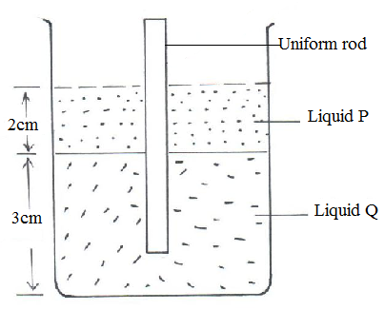
Determine
(i).the weight of liquid P displaced by the rod. (3 marks)
………………………………………………………………………………………………………
………………………………………………………………………………………………………
………………………………………………………………………………………………………
………………………………………………………………………………………………………
………………………………………………………………………………………………………
………………………………………………………………………………………………………

(ii) The weight of liquid Q displaced by the rod. (2 marks)
………………………………………………………………………………………………………
………………………………………………………………………………………………………
………………………………………………………………………………………………………
………………………………………………………………………………………………………

(iii) The mass of the rod. (1 mark)
………………………………………………………………………………………………………
………………………………………………………………………………………………………
………………………………………………………………………………………………………

(iv)The density of the rod. (2 marks)
………………………………………………………………………………………………………
………………………………………………………………………………………………………
………………………………………………………………………………………………………

(c). Figure below shows a block of volume 50 cm³ and density 2 000 kg/m³ submerged in a liquid and suspended from a uniform horizontal beam by means of a thread. The beam is balanced by a spherical mass of 40 g, which is suspended from it on the other side of the pivot as shown
Determine the upthrust force acting on the block. (3 marks)
………………………………………………………………………………………………………
………………………………………………………………………………………………………
………………………………………………………………………………………………………
……………………………………………………………………………………………………...
………………………………………………………………………………………………………
……………………………………………………………………………………………………....
16. a) State two condition necessary for a driver to negotiate a bend on a banked bend at a relatively high speed (2 marks)
………………………………………………………………………………………………………
………………………………………………………………………………………………………
………………………………………………………………………………………………………

(b).The figure shows stone of mass 100g whirled in a vertical circle using a thread of length 56cm. (Take g 10N/Kg)
If the stone is whirled at a speed of 8m/s. Calculate;
i) The centripetal force experienced by the stone. (3 marks)
………………………………………………………………………………………………………
………………………………………………………………………………………………………
………………………………………………………………………………………………………
……………………………………………………………………………………………………....
ii) Tension force on the string:
I) T_{A} (2 marks)
………………………………………………………………………………………………………
………………………………………………………………………………………………………
………………………………………………………………………………………………………
……………………………………………………………………………………………………....
II) T_{B} (2 marks)
………………………………………………………………………………………………………
………………………………………………………………………………………………………
………………………………………………………………………………………………………
……………………………………………………………………………………………………....
iii) calculate the angular velocity of the stone. (1mark)
………………………………………………………………………………………………………
………………………………………………………………………………………………………
………………………………………………………………………………………………………
………………………………………………………………………………………………………

(d)Figure shows a centrifuge that is used to separate particles suspended in a liquid.
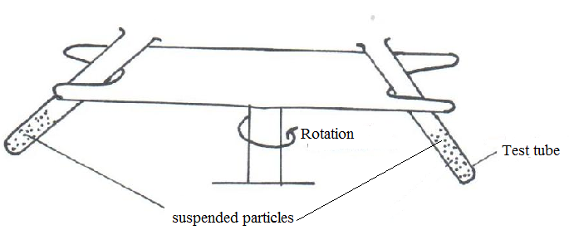
Particle of different mass M₁, M₂ and M₃ are suspended in a liquid which they do not dissolve. The system is then rotated in the direction shown.
(i).Explain why the particles of different masses will acquire different radii as the system is rotated. (1 mark)
………………………………………………………………………………………………………
………………………………………………………………………………………………………
………………………………………………………………………………………………………

(ii).If M₃, >M₂> M₁, arrange the particle in increasing radii when the centrifuge is rotated for some time. (1 mark)
………………………………………………………………………………………………………

17.a) State the one condition necessary for pressure law to hold. (1 mark)
…………………………………………………….………………………………………………
…………………………………….………………………………………………………………

b) A bubble at the bottom of a pond expands as it rises to the top of the liquid. Explain. (1 mark)
…………………………...………………………….………………………………………………
……………………………...……….………………………………………………………………
………………………………………………………………………………………………………

c) The graph below represents a graph of pressure against temperature, ºC.

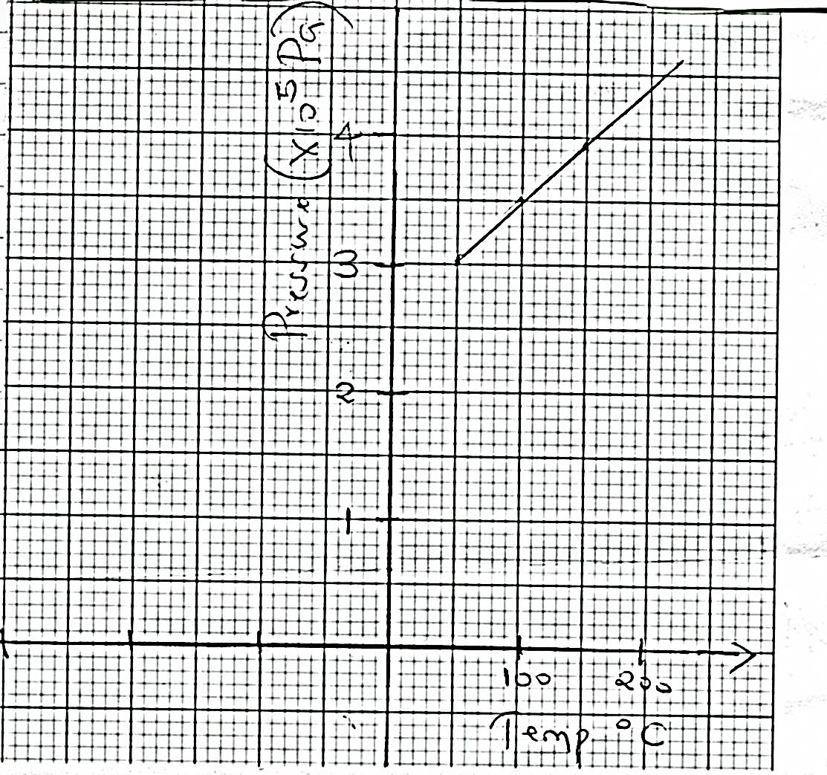
Pressure (×10⁵Pa)
4
3
2
1
Temp ⁰C
200
100
From the graph, determine;
i)The absolute temperature. (1 mark)
………………………………………………………………………………………………………
………………………………………………………………………………………………………
Ii)The pressure at 373K (1 mark)
………………………………………………………………………………………………………
………………………………………………………………………………………………………

Explain why temperature in (i) above can not be achieved (2 marks)
…………………………...………………………….………………………………………………
………………………………………………………………………………………………………
………………………………………………………………………………………………………
………………………………………………………………………………………………………

d) A column of air 26cm long is trapped by mercury thread 5cm long. When the tube is inverted, the air column becomes 30cm long.What is the value of atmospheric pressure? (3 marks)
…………………………...………………………….………………………………………………
……………………………...……….………………………………………………………………
……………………………………………………………………………………………………….
Explain using kinetic theory of gases why pressure of gases increases as temperature of the gas is increased. (3 marks)
………………………………………………………………………………………………………
………………………………………………………………………………………………………
………………………………………………………………………………………………………
………………………………………………………………………………………………………
………………………………………………………………………………………………………

18. a) Differentiate between work and energy. (2 marks)
………………………………………………………………………………………………………
………………………………………………………………………………………………………
………………………………………………………………………………………………………
………………………………………………………………………………………………………
………………………………………………………………………………………………………

b) Describe the energy transformation that takes place when a car battery is used to light a bulb. (1 mark)
………………………………………………………………………………………………………
………………………………………………………………………………………………………
………………………………………………………………………………………………………

c) The figure shows a machine.
Gear wheel A with 30 teeth is driven by gear wheel B with 15 teeth.
i) Determine the velocity ratio of the machine. (2 marks)
…………………………………………………………………………………………………………………………………………………………………………………………………………………………………………………………………………………………………………………
ii) If the machine has a mechanical advantage of 0.375, determine the efficiency of the machine. (2 marks)
…………………………………………………………………………………………………………………………………………………………………………………………………………………………………………………………………………………………………………………
d) A cart of mass 30kg is pushed along horizontal path by a horizontal force of 8N and moves with a constant velocity. The force is then increased to 14N.
Determine:;
i) The resistance to the motion of the cart. (1 mark)
…………………………………………………………………………………………………………………………………………………………………………………………………………………………………………………………………………………………………………………
ii) The acceleration of the cart. (2 marks)
……………………………………………………………………………………………………………………………………………………………………………………………………………………………………………………………………………………………………………………………………………………………………………………………………………………………………………………………………………………………………………………………

